2/20/2024

House

Bearshares

BearShares

Copyright Platform

Contents

**Summary:** 2

**Objectives:** 3

**Revenue Model:** 3

**Development Plan:** 4

Phase 1: Platform Development (Months 1-3) 4

Phase 2: Launch and Initial Marketing (Months 4-6) 4

Phase 3: Optimization and Scaling (Months 7-12) 5

**Financial Projections:** 5

**Conclusion:** 6

**BearShares: ERC-404 NFT Copyright Platform**

# **Summary:**

In the ever-evolving landscape of digital assets, BearShares emerges as a pioneering force, set to redefine the NFT experience. Our primary goal is to empower digital content creators with a secure and transparent platform that not only protects their intellectual property but also ensures the authenticity of the assets they create.

At the heart of BearShares is the development of an innovative ERC-404 NFT token, meticulously crafted to serve as a symbol of trust and integrity within the NFT ecosystem. This token will be the cornerstone of our platform, facilitating secure copyright transactions for creators who seek to protect their unique digital creations.

One of our key business objectives is to eliminate the threat of forged or scam NFTs. By implementing cutting-edge features, we aim to provide a forge-proof identification system, granting peace of mind to both creators and collectors. This commitment to authenticity extends to the very core of our platform, ensuring that each NFT on BearShares is a genuine representation of its creator's work.

In pursuit of sustainability, we introduce a novel revenue model. Creators pay a one-time fee to copyright their digital content on our platform, initiating a journey where their work is safeguarded and appreciated. Additionally, the built-in burn functionality adds a layer of scarcity, enhancing the long-term value of the ERC-404 tokens.

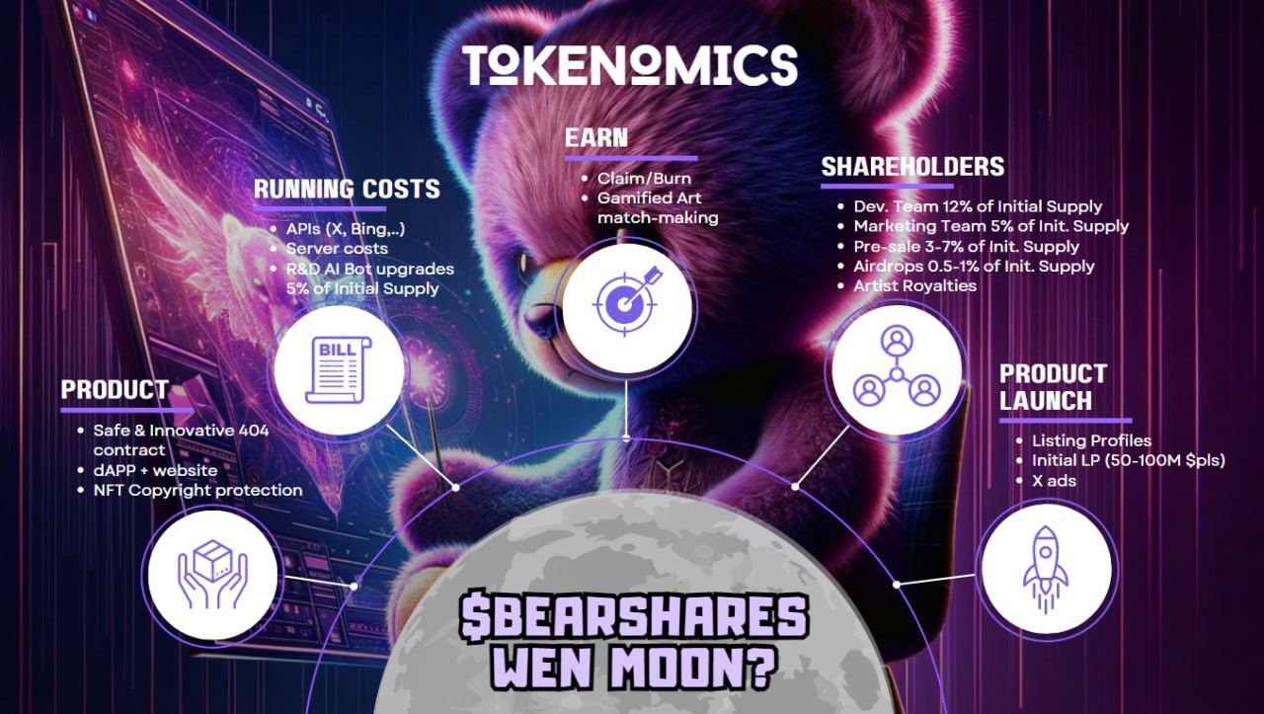The BearShares platform goes beyond a mere transactional space; it aspires to be a thriving community where creators and collectors converge. Our user-friendly interface facilitates easy copyrighting, while our robust marketing strategy aims to foster a vibrant community. We believe in the power of collaboration and aim to create an ecosystem where digital creativity flourishes.

Looking ahead, BearShares envisions a future where digital assets are respected, protected, and seamlessly exchanged. With a focus on continuous improvement, community engagement, and scalability, we embark on a journey to redefine the NFT landscape, making BearShares the go-to platform for creators who value authenticity, integrity, and financial sustainability.

# **Objectives:**

BearShares aims to revolutionize the NFT space by introducing an ERC-404 NFT copyright platform. The ERC-404 token will empower users to copyright their digital content and identify forged or scam NFTs. The revenue model includes a built-in burn function and royalties collected through ERC-404 fractionalized swapping. This platform will serve as a secure and transparent solution for digital content creators, ensuring the integrity of their work while providing a sustainable revenue stream.

1. Develop a Secure Copyright Platform:
   1. Create an ERC-404 token that facilitates secure copyright transactions for digital content creators.
2. Forge-Proof NFT Identification:
   1. Implement features to identify and prevent forged or scam NFTs, ensuring the authenticity of digital assets.
3. Built-In Burn Functionality:
   1. Incorporate a built-in burn function to increase scarcity and value over time.
4. Royalty Collection through ERC-404 Fractionalized Swapping:
   1. Enable users to set up royalties for their copyrighted content and facilitate royalty collection through ERC-404 fractionalized swapping.
5. User-Friendly Interface:
   1. Develop an intuitive and user-friendly platform for creators to copyright their digital assets easily.
6. Marketing and Community Building:
   1. Implement a robust marketing strategy to build a strong community of digital creators and collectors.

# **Revenue Model:**

1. One-Time Copyrighting Fee:
   1. Users pay a one-time fee to copyright their digital content on the BearShares platform.
2. Royalties:
   1. Creators earn royalties each time their copyrighted content is sold, traded, or transferred.
3. ERC-404 Fractionalized Swapping Fee:
   1. A small fee is charged when users engage in fractionalized swapping of ERC-404 tokens, providing a continuous revenue stream.

# **Development Plan:**

## Phase 1: Platform Development (Months 1-3)

1. Smart Contract Development:
   1. Create ERC-404 token with copyright and identification functionalities.
2. User Interface Development:
   1. Design and develop a user-friendly platform for copyrighting and managing NFTs.
3. Security Audits:
   1. Conduct thorough security audits to ensure the platform's robustness

## Phase 2: Launch and Initial Marketing (Months 4-6)

1. Platform Launch:
   1. Release the BearShares platform to the public.
2. Marketing Campaign:
   1. Implement a comprehensive marketing strategy to attract creators and collectors.
   2. Evaluate marketing needs and allocate budget accordingly

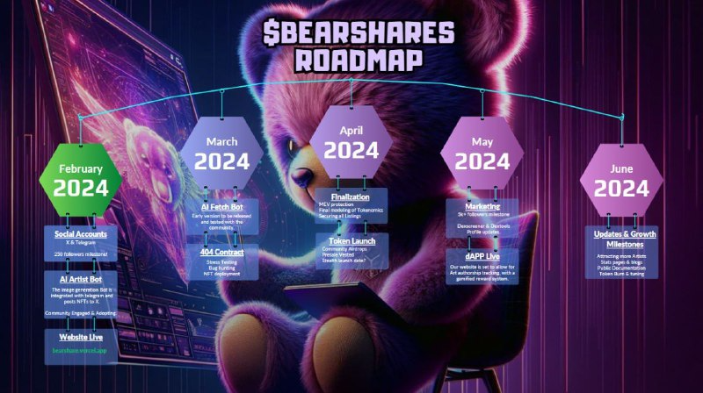

1. Community Engagement:
   1. Build an active community through social media, forums, and events.

## Phase 3: Optimization and Scaling (Months 7-12)

1. Feedback Integration
   1. Gather user feedback and make necessary platform optimizations
2. Scaling Infrastructure:
   1. 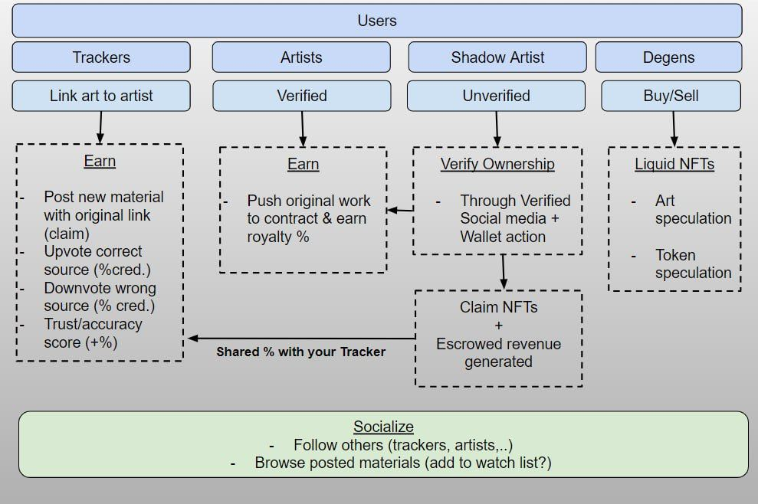Scale server infrastructure to handle increased user traffic.

# **Financial Projections:**

This monthly breakdown provides a clear understanding of how the startup costs will be distributed over the first three months for the initial launch and how the ongoing monthly expenses will be allocated for the subsequent months, considering server costs and potential scalability

1. Initial Launch Costs (Months 1-3):
   1. Contract work, server costs, and development: $1,200 max
      1. Month 1:
         1. Contract Work (One-time Fees)
            1. Front-end development: $500
            2. Graphic designer (optional): $100
      2. Month 2:
         * 1. Server Costs (Monthly)
           2. Web Server (AWS): ~$0 to $20
           3. Reverse Image Search Integration (Google API): $100
      3. Month 3:
         * 1. Server Costs (Monthly)
           2. AI Server (AWS) for Training & Execution (G4 instances): ~$325 to $750
           3. AI Server (AWS) for Image Generating (OpenAI DALL E - 3): $105
2. Monthly Running Costs (Months 4-24):
   1. Server costs and ongoing development: ~$550 to $750 per month
3. Revenue Generation:
   1. Projected revenue growth based on user adoption and NFT transactions.
4. Profitability Projection:
   1. Expect profitability to be achieved within the first year of operation.

# 

# **Conclusion:**

BearShares aims to create a secure and transparent environment for digital content creators in the NFT space. By combining copyright protection, forgery prevention, and a sustainable revenue model, BearShares endeavors to be a leading platform in the evolving world of digital assets.

